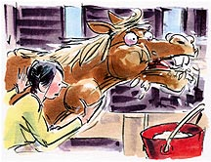
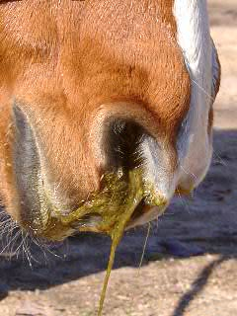
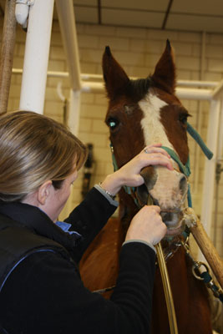
First Aid: Choke
What is it?
Don't panic, the term “choke” in horses indicates food stuck in the esophagus rather than in the trachea so you horse will not suffocate.
How does it happen?
Usually it occurs when a horse bolts it's food either because they are just a fast eater or because they are concerned that another horse will try to steal their food.
What does choke look like?
Horses usually have feed material mixed with saliva coming out of both nostrils. They also periodically assume a characteristic stance with the neck lowered, and tensed, especially the muscles underneath the neck and the head extended. You can sometimes palpate a mass in their esophagus. It looks awful, but it isn’t immediately life threatening.
What to do?
Call your vet and remove all food and water from the horse. Do not “help” the horse by shoving a hose down their mouth and turning it on; the water can just as easily go into the lungs and cause the horse to end up with pneumonia. Instead try to keep your horse relaxed, sometimes gently massaging the underside of the neck can encourage the mass to pass.
What is the prognosis?
The good news is that many of these resolve on their own before the vet can drive to the farm, however the longer food remains lodged in the esophagus the more you increase the risk of the horse breathing in some of the food stuff leading to aspiration pneumonia. Also, the mass can scar the esophagus if not removed in a reasonable period of time, leading to a narrowing of the esophagus and predisposing the horse to future choking episodes.
What does treatment for choke look like?
The veterinarian will often administer injections to help with muscle relaxation and sedation which may allow the mass to pass. This is usually followed by passing a nasogastric tube and carefully lavaging (flushing) with water to physically push the mass down into the stomach.
How can I prevent choke?
If you have a known bolter you can place large rocks (too big for them to eat) in their feed tub so they have to pick around them to eat their grain. If you feed pelleted feed you can add water to make it into a mash that the horse licks up.

